LBYCPA1

**Programming Logic and Design Laboratory**



*(Note: you can change the image to your own liking)*

**Laboratory Module 4**

Control Structure – Loops

By

John Carlo Theo S. Dela Cruz | LBYCPA1 | EQ1

# INTRODUCTION

Fourth Module of this course will mainly focus on Control Structures more specifically looping statements. According in the module 4, Looping statements is a flow control statements that are always present in every aspect in the programming field; it is widely used and incredibly important. Looping from the word loop, it executes the same code within a specific condition or number of times. A basic differentiation between while and for loop is: While loop statement loops a certain code within a certain condition is satisfied or is true, and For loop statement repeats the code within a certain range. In this module, we will be focusing ourselves on how we can use the looping statements and use these statements to create a program with the knowledges from our past modules.

The main objective

**In general, what is this module all about?**

The primary job of any scientific Introduction is to establish the purpose for doing the experiment that is to be reported. When scientists do research, the main purpose that guides their work is to contribute to the knowledge of their field. That's why the scientific context they establish in their introductions usually consists of summarizing previous research reports published in the field. A scientific contribution to the knowledge of the field can be understood only within the context of what other scientists have done.

The main purpose of writing a lab report, of course, is not to contribute to the knowledge of the field; but to provide you the opportunity for learning. That's why it's important to begin the lab by establishing that learning context. The learning context provides a way for you to situate the lab report within the overall purpose for doing the lab in the first place: **to learn something about the science of the course you are taking**. Another goal of your introduction is to let your readers know what they can expect from this module. One to two paragraphs are enough.

**What do you think are the main objectives for this module? (Enumerate as many as you can.)**

1. Objectives
2. To familiarize with the use of FOR and WHILE Looping statements
3. To generate arithmetic progression using the range () function
4. To solve computational problems using looping statements
5. To use and adapt the knowledge in Looping Statements with the use of Karel the Bot.

**What are the materials used for this module?**

1. Materials and Tools
2. Instructor's lecture notes
3. Jupyter Notebook
4. Flowchart Software (Diagrams.net, Lucidchart, SmartDraw, etc.)
5. etc.

# PROCEDURES (*Individual*) / EXPERIMENTAL PLAN

There are various other headings one may find for this section of the report, such as "Experimental Procedure," "Experimental," or "Methodology." Sometimes Materials and Methods may be separated in different sections. But however it is titled, the main tasks of the Materials and Methods are to describe (1) the lab apparatus and the laboratory procedure used to gather the data or solve the problem and (2) the process used to analyze the data.

Materials and Methods takes the reader step by step through the laboratory procedure that the experimenters followed. The rule of thumb in constructing this section is to provide enough detail so that a competent scientist in the field can repeat, or replicate, the procedure. The challenge, however, is to do so as efficiently as you can. This means, for example, not including details that the same competent scientist already knows, such as descriptions of standard procedures that most everyone in the field would already be familiar with.

**Formulate your own plan, steps, or procedures that you followed for conducting the experiment/activity or in solving the modules activities provided**. Make your procedures easy to follow and as detailed as you can, e.g. Note: Include your own diagrams, pseudocode, and/or flowcharts.

1. In Familiarization Exercise 1, I created a new project in PyCharm named “HelloPython”. Once the workspace is opened, I created a file named “hello.py” and began typing the provided sample code….
2. In Familiarization Exercise 2, the procedure was similar to the one in (1), but I have researched first the formulas needed for solving the volume for basic 3D geometric shapes…
3. and so on ….

**The Introduction together with individual Procedures and plan comprises the Experimental Plan and Conducting Experiment/ Activity criteria in the Final Laboratory Report Rubric**:

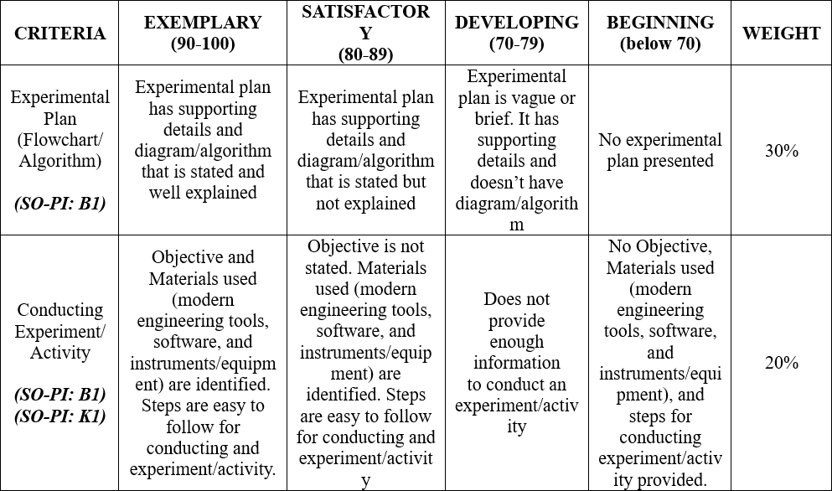

# RESULTS AND DISCUSSION/COMPUTATIONS (*Include the program output screenshots, and discussions per problem solution*)

This is the heart of the scientific paper, in which the researcher reports the outcomes of the experiment. Report is a key word here because Results should not contain any explanations of the experimental findings or in any other way interpret or draw conclusions about the data. Data and Results should stick to the facts as they have been observed.

Generally speaking, the Data and Results begins with a succinct statement (a sentence or two) summarizing the overall findings of the experiment. After that the Results integrates both visual (graphs, screenshots, tables, drawings) and verbal (words) representations of the data. The verbal descriptions consist of series of findings (general statements that summarize or give the important point of a visual) and support for the findings (further details about the data that give pertinent information about the findings).

#### Pattern: Screenshot + Explanation per result + Hand Computations

**1. Familiarization Exercise 1 Result:**

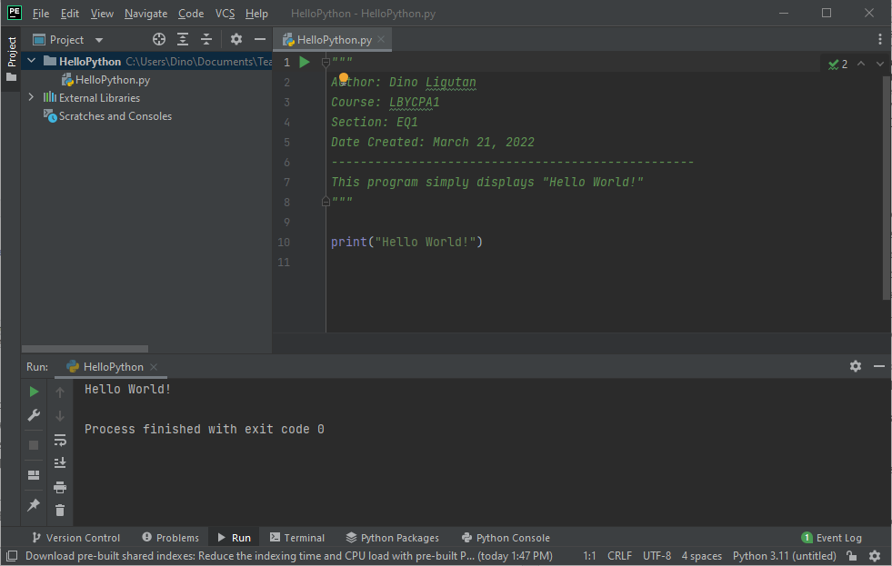

**Explanation:**

The one shown at the top of the program is called a multiline string. This can also be used as for multiline comments must begin with three double quotes (“““) and end with another three double quotes (”””). Anything between these two comment symbols is ignored by the compiler. As the name suggests, a multiline comment may be several lines long.

The last line of code calls the built-in function print() and it accepts a string as its argument. The supplied argument is the string “Hello World!” and the same output is shown at the Python Console below…

**2. Familiarization Exercise 2 Result:**

…

**The Results and Discussions constitutes the data criteria in the Lab Report Evaluation Rubric**:

# CONCLUSION:

The Conclusion returns to the larger purpose of the lab, which is presented as the learning context in the Introduction: **to learn something about the scientific or computational concept that provides the reason for doing the lab**. This is where you demonstrate that you have indeed learned something by stating what it is you have learned. This is important because it helps you to understand the value of the lab and convinces the reader that the lab has been a success. It's important, then, to be specific, providing details of what you have learned about the theory or principle or procedure at the center of the lab. The following guides questions should be answered to create a good conclusion:

**Did you achieve your objectives for this module? Describe your achievement in this module one-by-one, objective by objective. Ideally, each objective has its own paragraph.**

**What have you learned? Both technically (focused on programming), and in general (soft skills, attitude-related, etc.)**

**What are the common pitfalls, mistakes, and confusion that you have encountered? How did you overcome them?**

**What are your recommendations for those who will try the activity for the first time and what can you suggest to improve this module?**

**The rest of the rubric criteria are as follows:**

# REFERENCES (*Enumerate references in APA format*)

1. Parker James R. (2017). *Python : An Introduction to Programming*, Dulles, Virginia : Mercury Learning and Information.
2. Barry, Paul, (2016). [*Head First Python*](http://stackabu.se/head-first-python)*,* Second Edition*,* O'Reilly Media, Inc.
3. Lambert, Kenneth A., (2015). *Python Programming for Teens*, Boston, MA : Cengage Learning PTR.
4. Beazley, David and Jones, Brian K., (2013). [*Python Cookbook*. Third edition](http://stackabu.se/python-cookbook), O'Reilly Media, Inc.
5. Fangohr, H. (2015). *Python for Computational Science and Engineering*. Faculty of Engineering and the Environment University of Southampton.
6. Gowrishankar, S., & Veena, A. (2018). *Introduction to Python Programming*. Chapman and Hall/CRC.
7. Matthes, E. (2015). *Python crash course: a hands-on, project-based introduction to programming*. No Starch Press.
8. Miller, B. N., Ranum, D. L., & Anderson, J. (2019). *Python programming in context*. Jones & Bartlett Learning.
9. Sweigart, A. (2015). *Automate the boring stuff with Python: practical programming for total beginners*. No Starch Press.
10. LabWrite Project 2000, *“The Parts of a Laboratory Report”*. URL: https://projects.ncsu.edu/labwrite/res/res-studntintro-labparts.html (accessed 02/20/2020)

This is a list of the references that were cited in the lab report, including the lab manual, any module handouts accompanying the lab, the textbook, and sources from the scientific literature. The format for references differs in different fields and even within the same field. It's important that you check with your teacher or lab manual to find out what is expected of you.

# APPENDIX (*Attach all the source codes here per problem category*)

1. Familization Exercise 1:

*"""  
Author: Dino Ligutan  
Course: LBYCPA1  
Section: EQ1  
Date Created: March 21, 2022  
--------------------------------------------------  
This program simply displays "Hello World!"  
"""*print("Hello World!")

2. and so on …